## 

## Merchant

Demo date: Nov 21, 2024  
Scoping start date: Nov 21, 2024

MSA Signature Date: Nov 22, 2024  
Onboarding Kick Off Date: Dec 2, 2024

[If Exists] Opt Out Date:   
Go Live Date: Dec 23, 2024

GTM POC: Ben  
Implementation POC: Royce

ERP: QBO

Tax Integration: Avalara

### 

### Key people at Merchant

### Accountant: Ignite Spot Accounting, partner deal, Corbin- Director of Onboarding

### CEO: Rob Craig

### 

| Notes Sections [Ops International Team to Ignore] *(AE/ Implementation to fill)*   * Info on how merchant bills   + Recurring subscriptions with overage fees and late fees * Is there any important merchant relationship information? Caitlin: This is a partner client. Partner is Ignite Spot. They basically have all the up and coming Salt Lake City companies as clients. Trying to impress them   1) What is the merchant's temperament?  Super chill.  2) Is there a key POC: (i.e.: who is the buyer/decision maker?)  CEO - Rob Craig  3) What are the Tabs features that the key POC cares about?   * Forwarding contracts from Hubspot * Having better system to manage his tiered overage fees * More automated system to invoice - doesn’t like the manual workflow * Autocharge * Keeping track of renewals |
| --- |

### 

### Company summary *(AE to fill)*

Enzy.co offers a platform designed to improve organizational performance by streamlining workflows and boosting team productivity.

The company makes money by providing subscription-based software services tailored to sales, operations, and customer service teams. Their platform includes features like automated reporting, real-time performance tracking, customizable dashboards, and gamified incentives to enhance team engagement and efficiency. Enzy also provides specific tools for recruiting, onboarding, scheduling, and customer surveys, making it a comprehensive solution for businesses looking to optimize team management and operations​

Goals (North star)  
*(AE/ Implementation to fill)*

What is the merchant's goal? What pain are we solving? Why are they buying Tabs?

Automate invoicing, autocharging, and track late fees and tiered overage fees.   
  
Is there an opt out clause? If so, what is the merchant looking for so they do not exercise it?  
No opt out clause

### Billing model *(AE/ Implementation to fill)*

* Are there unique things about the customer creation process for this merchant?
* Information on how merchant bills
  + Wants to use primarily automatic methods like cc or ach debit. Wants to pass on cc fees to customer
* How contract is broken up
  + Caitlin can send over sample contracts to illustrate this. They are pretty simple
  + Bills some flat fee, some with tiered overages. Most seem to have one time implementation fees
* One off things to know about the merchant
  + 66 customers today

### Contract Processing Steps *(Implementation/Success to fill)*

[EXAMPLE GARAGE](https://garage.tabsplatform.com/prod/contracts/cf3d0290-054d-4cfd-b084-51db5209daf8/terms/revenue) PROCESSING [Listen to this video here on how to process](https://www.loom.com/share/72a3995f88e047528aa675c6e8df43dd?sid=4bd4beb5-47ed-46e7-8b35-fc59bbf82ac8) **(correction to some integration items, please refer to directions below)**

**When a new contract comes in:**

* **Customer is already created** 
  + Ping Ashni and Marshall for them to verify that BILLING contact is in merchant app
* **Customer needs creation**
  + Fill out with all the information that is in the billing contact section
    - **FOR EMAIL USE THE BILLING CONTACT SECTION. DO NOT USE THE IMPLEMENTATION CONTACT SECTION**

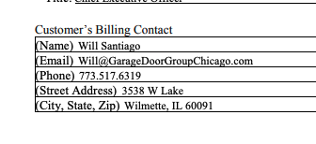

1. Steps to process:
   1. New format: de3fdb64-2911-452a-9c06-d64bc3280cf7
      1. The SOW effective date should still be the date the setup fee is sent out (the incorrect date was generated for this invoice ... 9/9/25 instead of 9/2/25
      2. The E-signed Documents usage line item should be mapped to "Documents Sent" product
      3. The outbound domestic SMS line item should be mapped to "Messages Sent" product
      4. Instead of a tiered approach for additional users, the usage fees section will show the price per additional user (e.g. $50) above the baseline committed user count (e.g. 10 users for Friendly Energy Solutions). So if the monthly users is 11, then additional $50 should be invoiced, 12 is $100, etc.

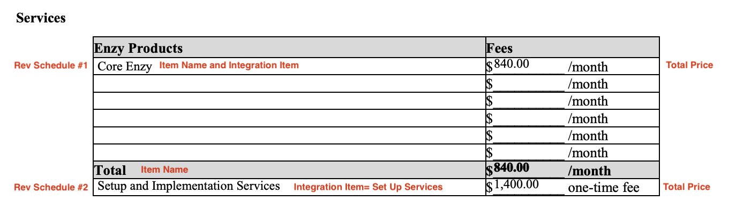

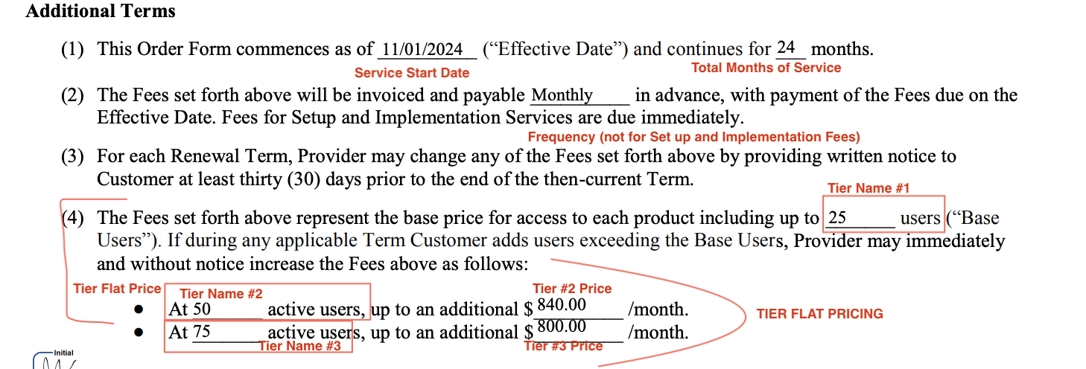Setup and Implementation Services

You will create a revenue schedule for each line item listed, in the screenshot above, there are 2 items so you will create 2 revenue schedules, if you see more line items, you would create a different revenue schedule. And then create a 3rd revenue schedule for Base Users

* + **Service Start Date:** See contract for effective date, refer to screenshot above for where to find.
  + **Total Months of Service:** 
    - PUT 2 MONTHS FOR IMPLEMENTATION
    - Default to 36 months for everything else
  + **Item Name:**
    - Match the name to the contract
  + **Item Description:**
    - Leave blank
  + **Integration Item: will always be the same as the line item** 
    - Setup and Implementation Services= Setup Services
    - Core Enzy = Enzy:Core Enzy *** DIFFERENT FROM WHAT WAS SAID ON LOOM VIDEO**
    - Canvassing Module= Canvassing Module
    - Please ensure the integration item lines up with each line item (should be a 1:1 match with the item name)
  + **Billing Type:**
    - Flat for Core Enzy
    - Flat for Setup and Implementation Services
    - Tier Flat Pricing for ACTIVE USERS- VOLUME BASED
  + **Total Price:**
    - Refer to contract
  + **Quantity**
    - Default 1
  + **Start Date:**
    - Start Date for **Set Up Fee:** Sign Date of Contract Net 0
      * If there is no signature date, we are using the SOW effective date; if there is no SOW effective date, we are using the Order Form effective date
    - **Start Date for other services**: Use the effective date
  + **Periods**
    - 36
  + **Frequency**
    - NONE for Implementation Services
    - 1 month for all other line items if stated as billed monthly
  + **Net Terms**
    - 0 for all
* How to make revenue schedule for **TIER FLAT PRICING**
  + **Name: Additional Users  
    Billing type:** Tier Flat Pricing
  + **Event to track:** Active Users
  + **Start Date:** Same as other rev schedules refer to contract
  + **Periods:** Refer to contract, length of contract in months
  + **Frequency:** Monthly

**Net Terms :** 0 for implementation services

* + 30 default for other services and line items
  + **Create a tier for the:**
    - **Users included (**example 25 users)
    - **And any other bullets that include users and pricing (**example: At 50 users, at 75 users)

Anything to ignore in contracts?

1. Specifics processing things the merchant has requested that may differ by contract (e.g. always back-date invoice date to final day of the month)
2. Default Service Term
   1. Refer to contract
3. Default Net Payment Terms
   1. 0 for all
4. Default Billing Frequency
   1. If None Listed, Ops Default is Monthly
5. How do we handle taxes as a line item?
   1. If None Listed, Ops Default is every tax line item becomes a BT

### Events Processing (if necessary) *(Implementation/Success to fill)*

* Any important information on events billing

Integration Items Processing (if necessary)  
*(Implementation/Success to fill)*

* What are the instructions for assigning integration items?
* Example: All Statsig integrations items should be labeled as “Sales”
* Example: All “Pinata” integration items should be labeled as “Software Subscription Bundle” unless otherwise noted by Merchant

Post Processing Communications (if necessary)  
*(Implementation/Success to fill)*

* Does the Ops Team need to notify anyone on the team re: completion of processing batches in Implementation or Active phase?
* Who needs to be notified and when?
  + Example:
    - Who: Customer Success [Azmat Aziz] needs to be notified
    - Where: Messari internal merchant channel
    - When: contracts are processed [Merchant Phase: Active]

### Customer Information *(Implementation/Success to fill)*

* Any important information on specifics customers of this merchant
  + Special memo’s certain invoices require
  + Invoice changes due to merchant/customer relationship

### Feature Requests *(AE/Implementation/Success to fill)*

* FR 1
  + What is it
    - Wants us to decouple one time implementation fees they charge from renewals. We currently cannot discern what is one time vs. recurring
    - Wants a select all button for schedule sending invoices
  + Why it's important
    - Workflow efficiency
  + Urgency
    - Not urgent

### Rewatch Calls *(AE/Implementation/Success to fill)*

* Rewatch by dates
* <https://tabs.rewatch.com/video/dm7bpjk91yeb89gg-enzy-tabs-implementation-scoping-november-22-2024>
* Custom demo:
  + <https://tabs.rewatch.com/video/9fvjlk9bp83yhfos-tabs-custom-demo-for-enzy>
* First call:
  + <https://tabs.rewatch.com/video/7fbb8kbz8az65k3z-tabs-enzy-intro-call>